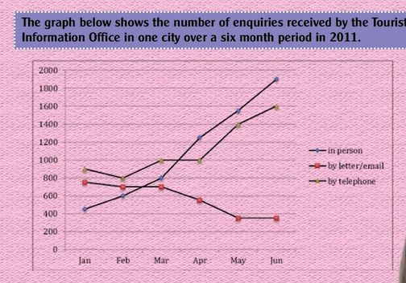

The line graph illustrates the quantity of enquries received by the Tourist Inforamtion Office in a certain city from january to Jun in 2011. Overall, the lines of enquirties taken in person and by letter or email experienced a huge rise from the beginning, while the the line by telephone showed a downward trend. In january, The face to face and telephone line started at around 400 and about 900 respectively. However, during Januray and feburary, the directed enquiries line decrease slowly, while the telephone line grew gradually before both surging in the following month and hitting the peak at the end of period at around 1900. It is noticeable that the equiries line in person exceeded the letter or email line in mid-feburary. In the mean time, the letter or email line started at 800 and remained stable for the next two months. After that, the figure decreased to approximately 400 and remained unchanged in the end of period

Bài mẫu

The line graph **compares** the numbers of questions that the tourist information office located in a city was asked by three ways in the first half of 2011/ from January to June 2011

It is clear that **asking information about travelling via letter or email** became gradually less common, **but the opposite was true for raising** questions in person and by making phone calls. In January, **telephone was the most widely chosen way for tourists to raise questions**, with about 900 received. The figure was **roughly** 200 higher than the quantity of questions in form of email and letter, and over 400 questions were asked face to face. **Over the next six moths**, this tourist information office received more questions via telephone, with its figure climbing to 1600. Similarly, the number of direct questions **rocketed and ranked top at the end**, with around 1900. In contrast, fewer tourists sent letter or email to request for information, and its figure fell to under 400 in June.

**Second try**



The line graph illustrates the quantity of questions were asked by the Tourist Information Office in a certain city from January to June in 2011

Overall, the line represents the number of enquiries were asked in person and by telephone experienced a upward trend, while the questions received by letter or email showed a downward phenomenon. In January, traveling questions asked via telephone started at around 900, higher than requests through telephone, letter or email 100 and 400 respectively. Although the figure fell gradually, but since Febuary it grew dramatically and hit its peak at the end of period. Similarly, the face-to-face questions rocketed from its beginning point, exceeding the two lines at mid-Febuary and mid march and reached the highest number among three communication methods in June. In contrast, the questions asked by letter or email remained unchanged during the first two months, then decreased significantly and hit the low-point at the end of period.